**OOP LAB 1:**

**UMM E FARWA**

**BS AI sec-B**

**F24ari0165**

**Task:01**

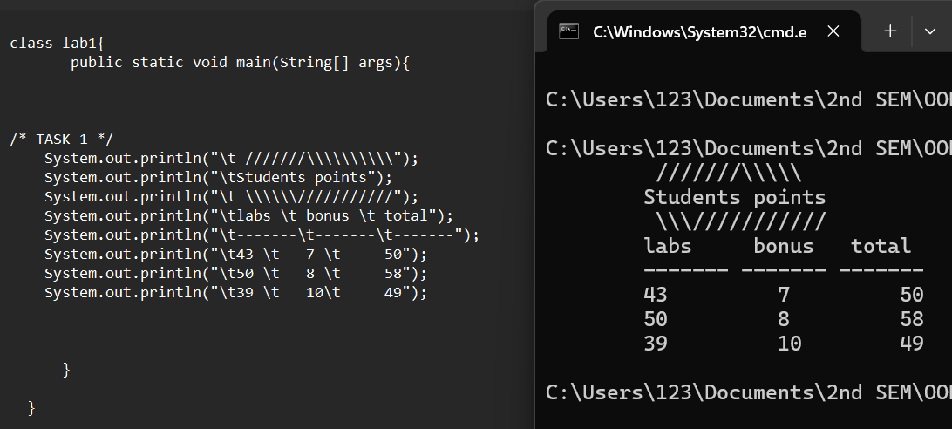

**Task:02**

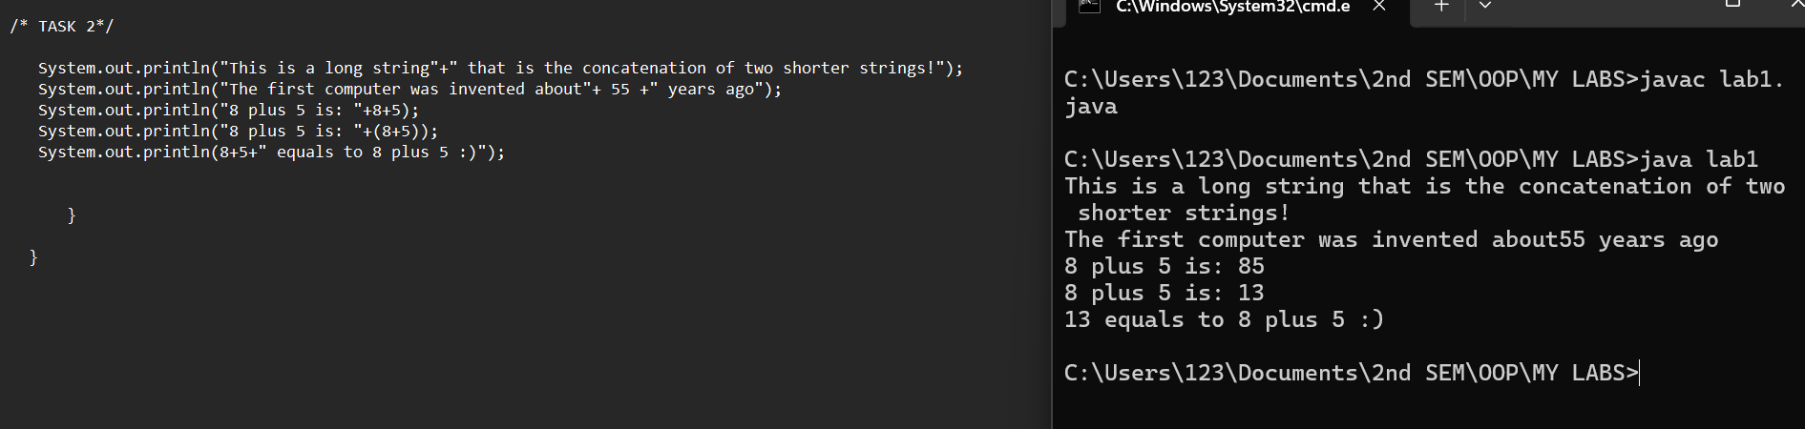

**Task:03**

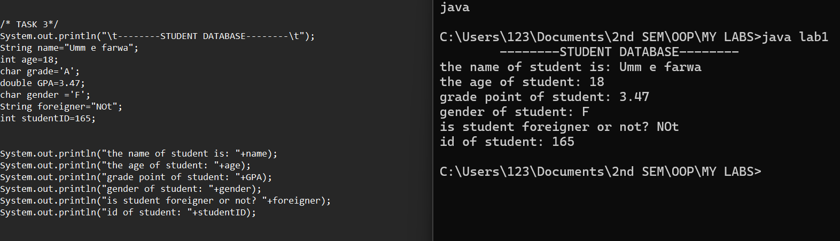

**Task:04**



**Task:05**

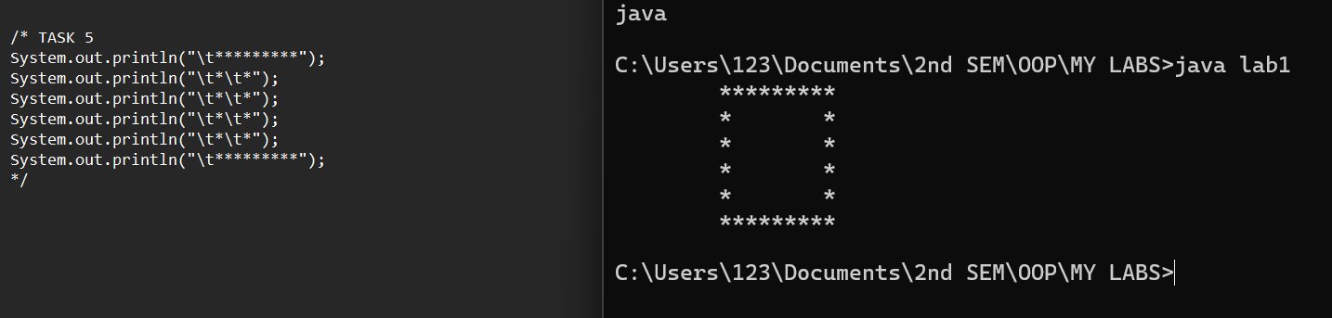

**Task:06**

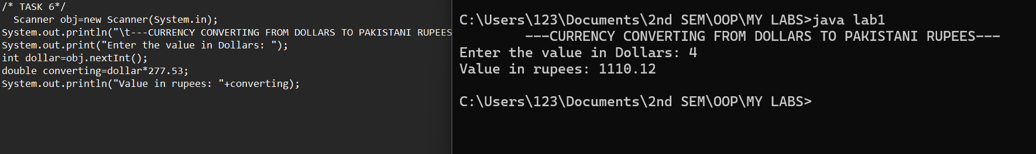

**Task:07**

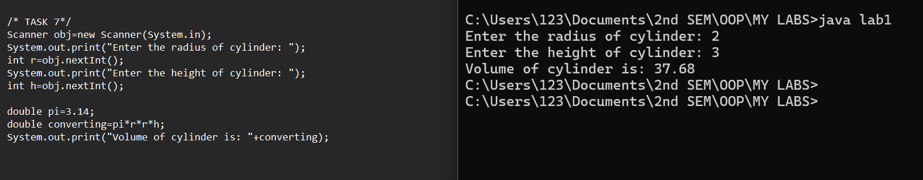

**Task:08**

**Sorry sir! My notepad was not working that’s why I did this task on VS code.**

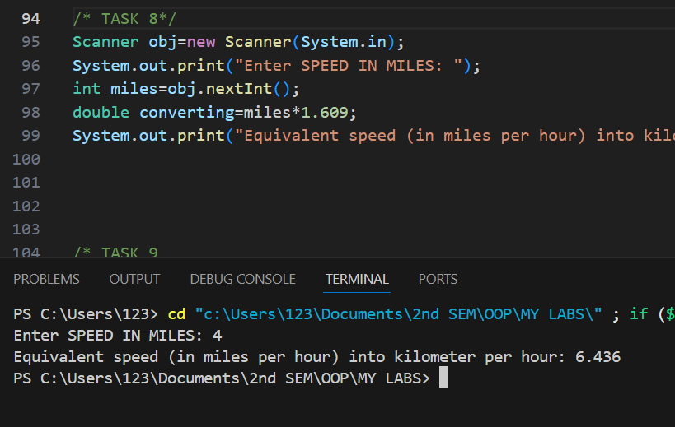

**Task:09**

